**18th October 2024 - Bozena Kuncewicz**

Polish Resettlement Camp Husband Bosworth/Sulby 1948 - 1958

In there 6 years after World War 2, hundreds of thousands of Polish civilians were brought to our shores and housed in more than 50 settlement camps. From 1914 to 1958, Husbands Bozworth was one of those camps.

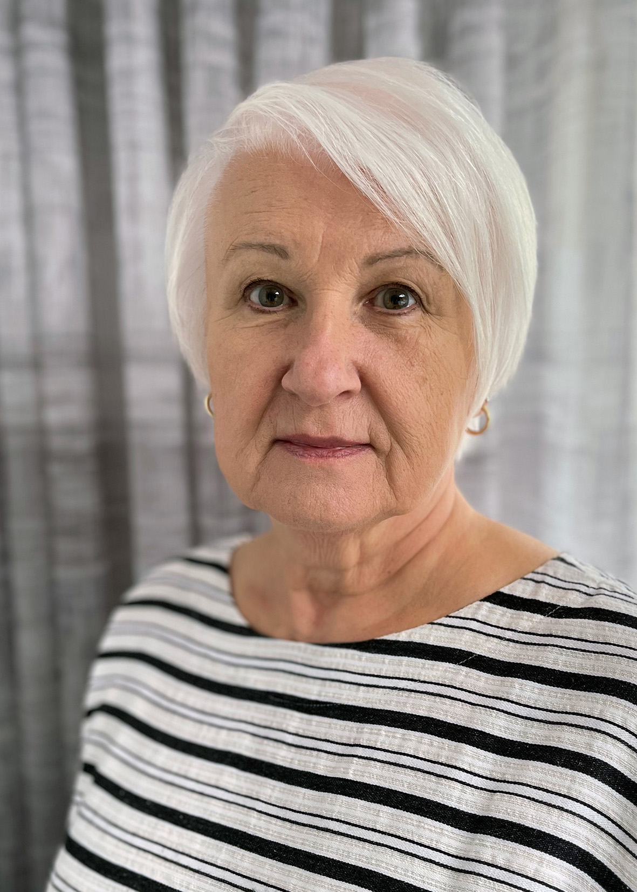

**15 November 2024 - Collin Bloor.**

Collin is one of our own u3a members and an outstanding photographer. In his talk, Collin will share with us images of nature and the landscape of Thrapston’s lakes and of the Thrapston area of the Nene Valley, throug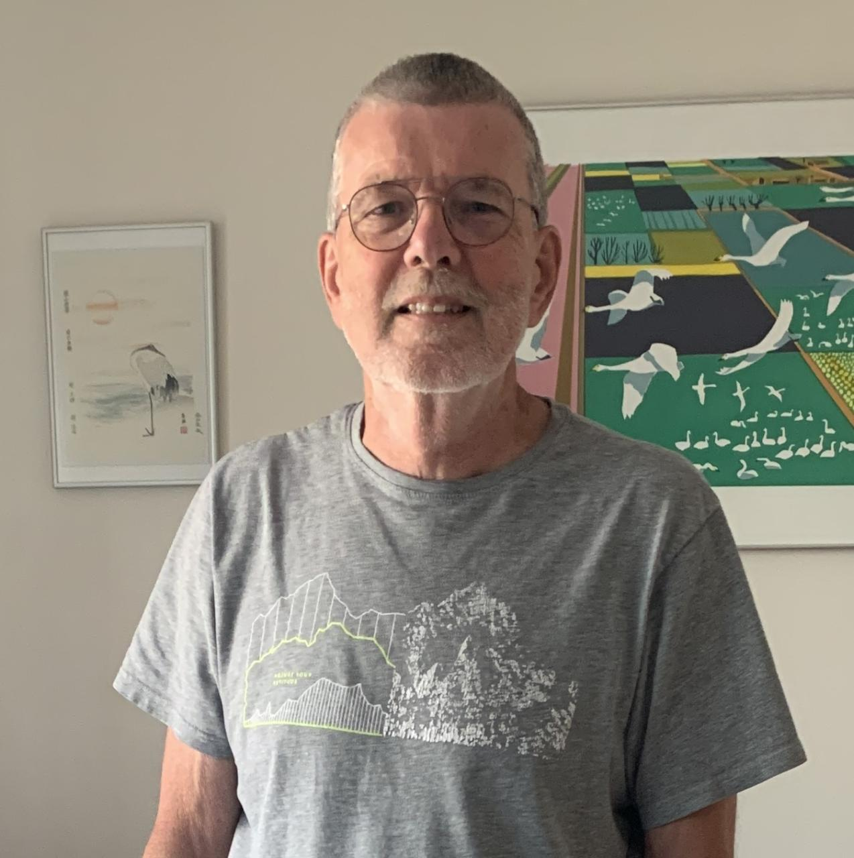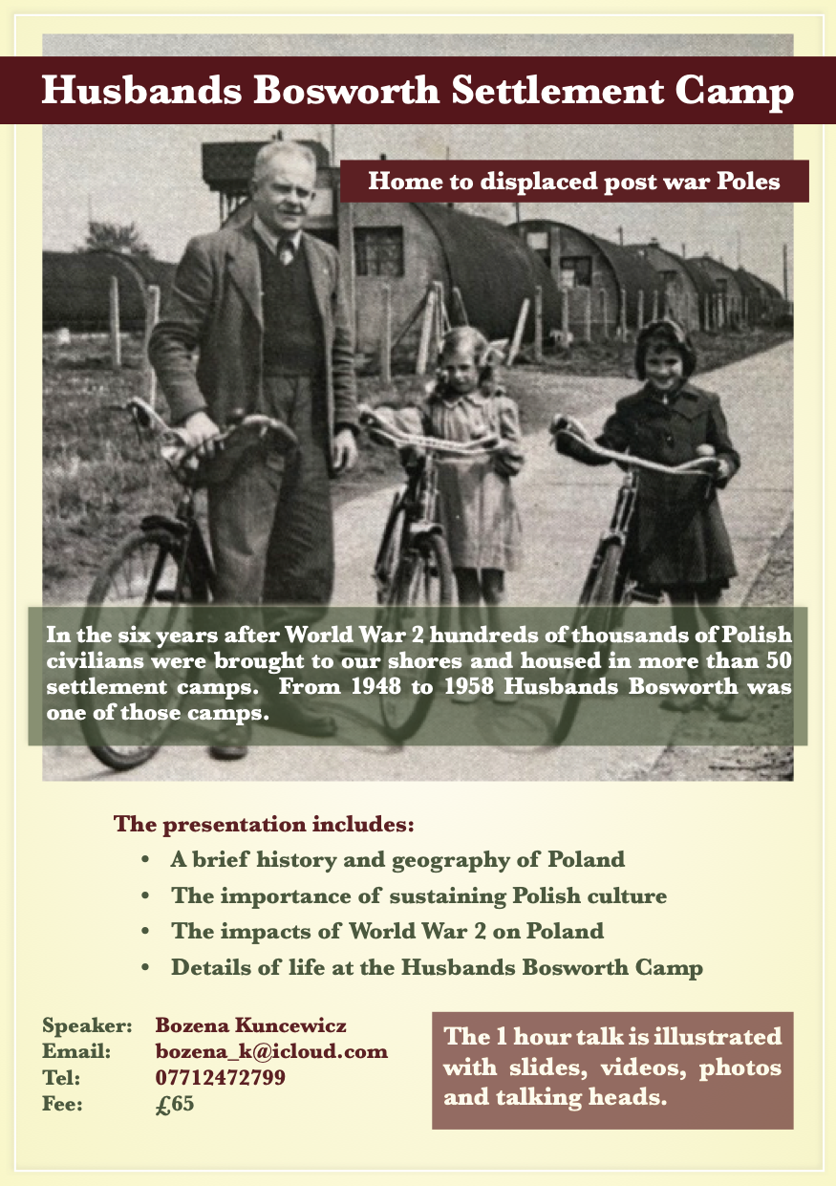h the seasons.

**17th January 2025 - Steve Bonham**

**The Great American Songbook. 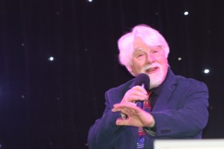**

Roger Browne is a professional raconteur, writer, director and pianist. He has appeared in jazz clubs and jazz festivals in the UK, Ireland, Germany, Norway, The Netherlands, Belgium, Switzerland and across North America and Canada, and provided piano accompaniment for many national and international legends such as Stefane Grappelli, Marion Montgomery, Wild Bill Davison, Scott Hamilton, Ray Nance, Bud Freeman, Humphrey Lyttleton, George Melly, George Chisholm, and many more.

Roger presents several talks on various aspects of American popular music from the early part of the twentieth century.

In this presentation, he focuses on the history, roots, and influences of “The Great American Songbook”, the lives and fascinating backs stories of the composers, lyricists and publishers who created this iconic genre during the first half of the Twentieth Century.

He discusses the influence of Jewish Immigrants from Central and Eastern Europe to New York, who went on to form what became known as Tin Pan Alley.

Expect hilarious anecdotes, incredible facts, and superb piano playing.

The presentation includes live performances of the compositions of Jerome Kern, Cole Porter, George Gershwin, Irving Berlin, Richard Rodgers, Oscar Hammerstein, and others.

**21st February 2025 - Steve Bonhampasted-image.tiff**

**Stumbling Over Eden.**

Following the narrative of a DIY trek from the top of the High Atlas Mountains to the Sahara desert (550 km),  Steve Bonham reflects on the nature of adventure and its rewards weaving in themes of risk-taking, serendipity and companionship. This is a celebration in story, bold ideas and song of the adventurer that lies within us all and invites us to see "beyond the adrenaline high" the true experience of stepping into the unknown and how to make a friend of uncertainty.