**Speakers Information for Publicity**

**March 2025 – Kenya, Britain’s Golden Colony – Michael Burton.**

Britain's most beloved colony was acquired almost by

accident. It attracted an array of characters – some to

work, creating a new life, some to “party,” and even

aristocrats seeking new fiefdoms. But it imploded

spectacularly after the Second World War as a result

of intractable problems centring on just one tribe.

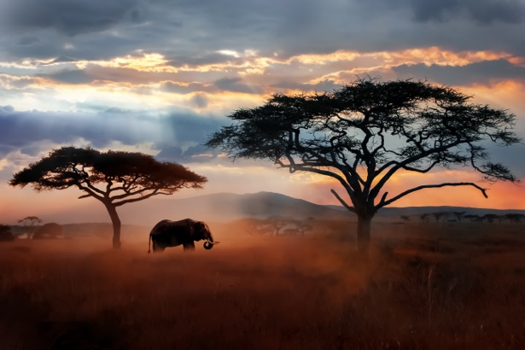

**April 2020 – Call of the Kingfisher – Nick Penny**

Call of the Kingfisher’ is the enchanting nature-writing debut from musician and wildlife recordist Nick Penny.

Discover why he describes his book as a “love letter to a short stretch of Northamptonshire’s River Nene” and celebrate a year of taking in the glorious sights and sounds of the riverbank.

As well as talking entertainingly about his experiences while researching and writing the book, Nick also performs some of his own live music on Harp and Handpan to accompany birdsong recordings he has made.

**May 2025 - The History & Mystery of the Victorian Punch & Judy Show – Mel Harvey**

Mel Harvey is an all-round professional entertainer, comedian, magician and if the picture is to be believed, musician. Mel’s talk covers the History and Mystery of the Victorian Punch and Judy show and includes a performance of the show. So, prepare to be taken back to sea-side memories of crocodiles and sausages and dripping ice cream.

**June 2025 – Every Body Tells a Story – David Sweeney**

Due to the public fascination in the use of forensic science in crime detection, this last period of David’s police career as a Forensic Detective, with many murders, un-explained deaths and funny stories felt a natural subject to share. Essex Police, David’s force, was a fore-runner in the development of the use of forensic techniques to solve crime. When he retired, David was one of the country’s top Fire Crime Scene Investigators and holds the Diploma in Crime Scene Examination from Durham University. He has featured on television on at least two of the famous murders he investigated. `The White House Farm Murders` and `The Meat Pie Murder of Westcliff-on-Sea, - as he says `Every Body tells are Story’.